Student: Pratyush Verma | Registration No: 24BCY10065
Project Component: SentinelTrapAI {Honeypot & Incident Response System}
SentinelTrapAI (VITGUARD)
System Architecture and Live Threat-Logging Output Verification
――――――――――――――――――――――――――――――――――――――――――――――――――――
EXHIBIT 1: Isolated Workspace & Modular Backend Directory Structural Architecture
This exhibit details the clean, headless project directory inside VS Code. The stack isolates backend configuration across structural files: db.py manages local asynchronous loops, models.py establishes Beanie schemas, and main.py coordinates core FastAPI endpoint bindings under a localized virtual environment environment (.venv).
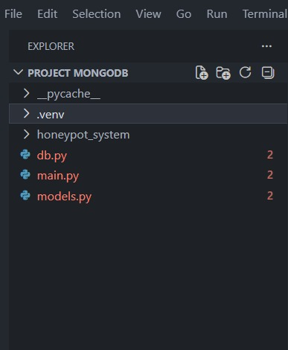
EXHIBIT 2: Real-Time Asynchronous Uvicorn Console Boot & Connection Verification Log
The live console log confirms a successful asynchronous MongoDB Honeypot database initialization connection. It maps concurrent network telemetry routes via ASGI-backed Uvicorn, capturing live intercept attempts, status codes (such as standard 200 OK channels), and handling malformed client entities cleanly.
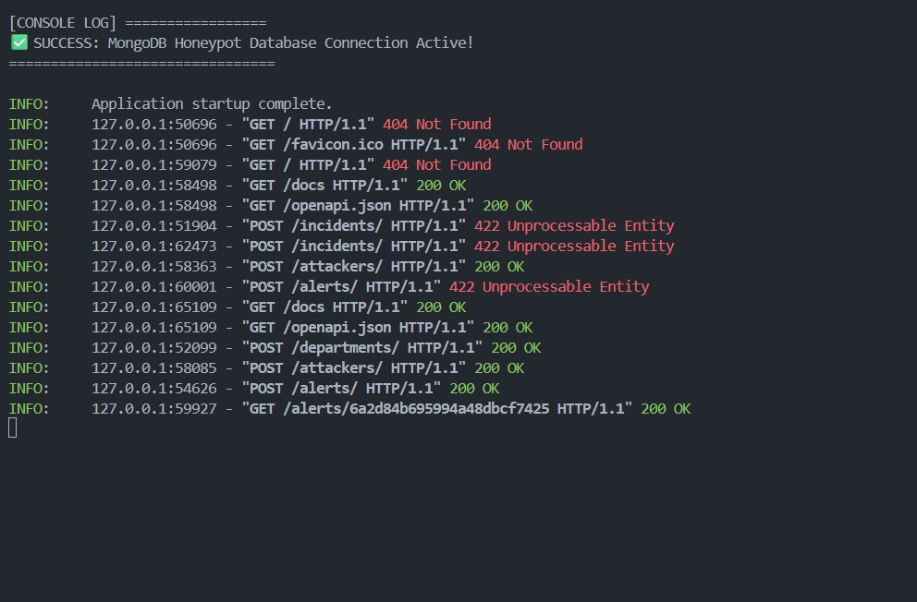
EXHIBIT 3: Headless Endpoint Definition & Testing Interface via Swagger OpenAPI Documentation
The automated Swagger UI dashboard replaces generic front-end overhead for security validation. Here, an administrative payload structure is compiled directly to issue a POST command to the /departments/ endpoint, establishing automated tracking for a targeted risk environment zone.
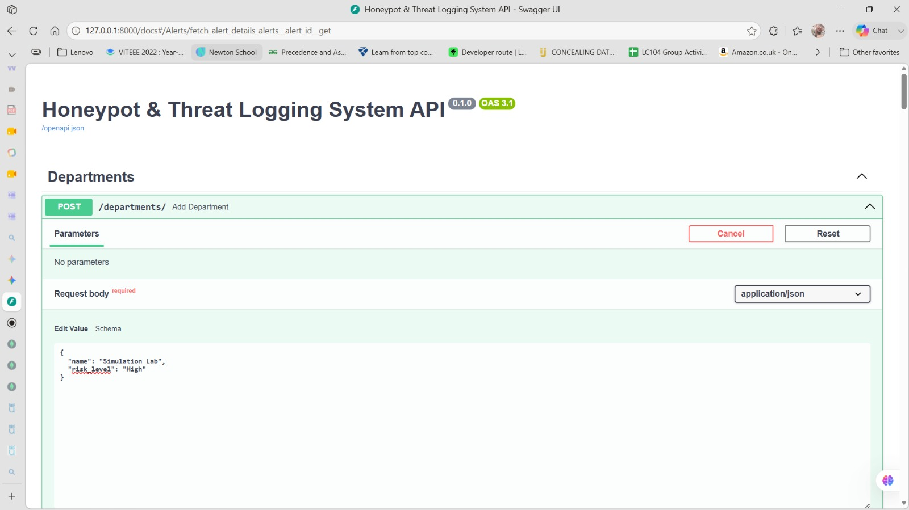
EXHIBIT 4: Programmatic Department Model Initialization and Live BSON Data Insertion
This record captures a successful server response (HTTP status code 200) confirming insertion of the 'Simulation Lab' tracking zone into MongoDB. The engine dynamically appends an exclusive system hexadecimal Object Identifier (_id) used for real-time document cross-referencing.
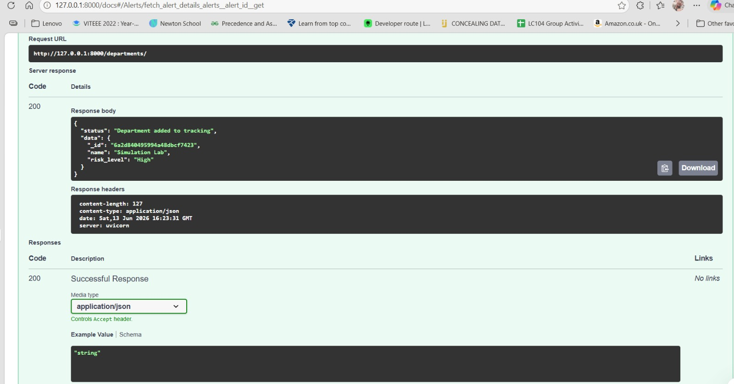
EXHIBIT 5: Normalization Event Mapping via Asynchronous Beanie ODM Document Referencing
This exhibit highlights advanced NoSQL document referencing in practice. When an active network exploit is registered, the incoming log references separate collections securely by recording system cross-pointers back to the assigned target_department and source_attacker records.
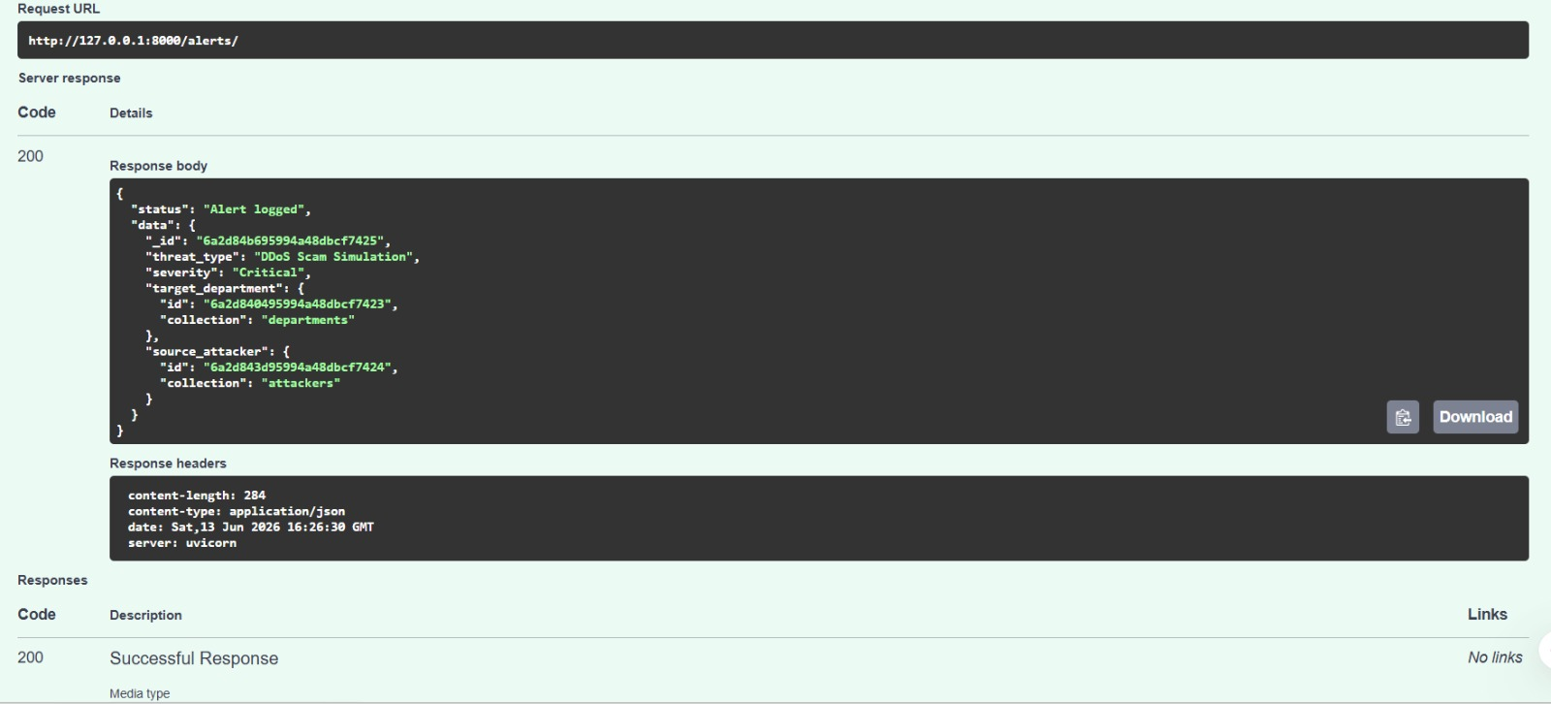
EXHIBIT 6: Forensic Telemetry Execution Query & Complete Adversary Payload Verification
This deep-dive record verifies specific threat payload lookup details. By evaluating the system hexadecimal alert hash ID, the FastAPI engine completely resolves object links to fetch details, exposing the adversary infrastructure footprint alongside tracking metrics.
